National Vegetation Classification Survey Form

Location: |  | Altitude:
Date: | Surveyors: | Slope:
Site vegetation and description: |  | DOMIN Cover Scale  91-100% is recorded as Domin 10  76-90% is recorded as Domin 9  51-75% is recorded as Domin 8  34-50% is recorded as Domin 7  26-33% is recorded as Domin 6  11-25% is recorded as Domin 5  4-10% is recorded as Domin 4  <4% with many individuals 3  <4% with several individuals 2  <4% with few individuals 1
 |  | 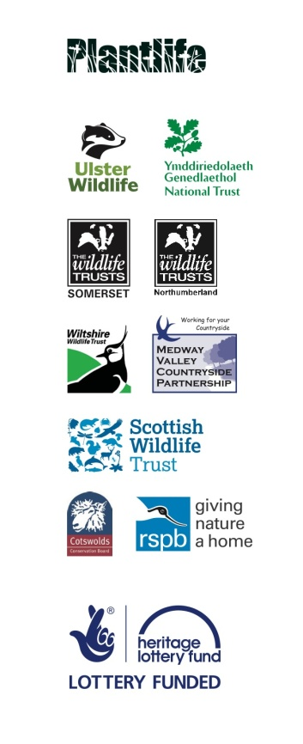

Quadrat | 1 | 2 | 3 | 4 | 5
Grid reference
Bare ground
Veg. height (cm)
No. species
Species | Cover using DOMIN

